Choice Price AB test finished on 2017-10-16 at 9:00 AM:

The Choice Price Test lasted for 59 days; the Test Group outperformed the Control Group in Revenue per Visitor,

1. The ATS of the Test Group is significantly higher than that of the Control Group, but the Conversion Rate of the Test Group is lower. The combined effect of the Test Price Offer is generating +6% lift in Revenue per Visitor over the Control Price Offer.
2. The conversion rate of the Test Group is -8% lower than that of the Control Group
3. The ATS of the Test Group is +14% Higher than that of the Control Group
4. All in all, the Test Group is giving us a +6% lift in Revenue per Visitor over the control Group
5. We noticed that the performance of the Test Price offer dropped significantly after a flash promotion between September 30th and October 5th. But the performance of the Test Price Offer had been climbing back steadily post promotion, and it outperformed the Control Price Offer in Revenue per Visitor by 4.5% at the end of the Price Test during the Post Promotion Period.

You can find the report here,

<https://data.points.com/#/views/ChoicePriceTestAug_17v2/Summary?:iid=1>

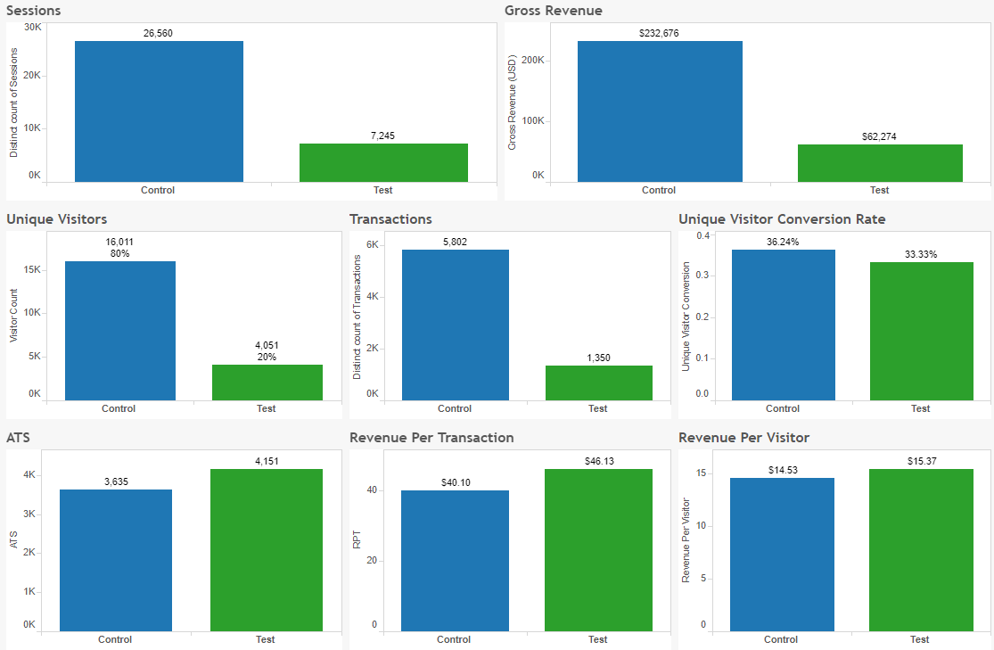

Post Promo

